Revenue Recognition

Log in to the FASB (Financial Accounting Standards Board) Accounting Standards Codification using this link:
http://www2.aaahq.org/ascLogin.cfm
with the username:
AAA52784
and the password:
Gb4X9uC
This will take you to a web page of the American Accounting Association with this choice:
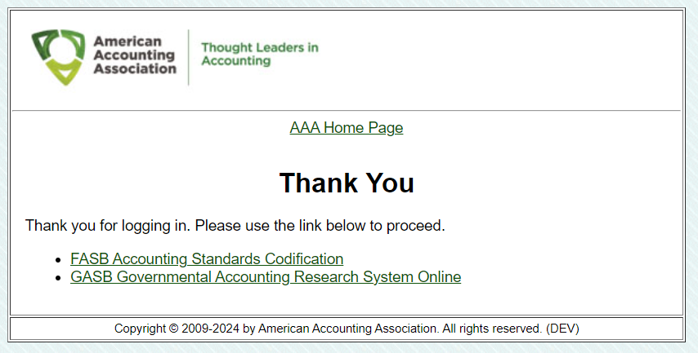
Choose FASB Accounting Standards Codification and work your way to:
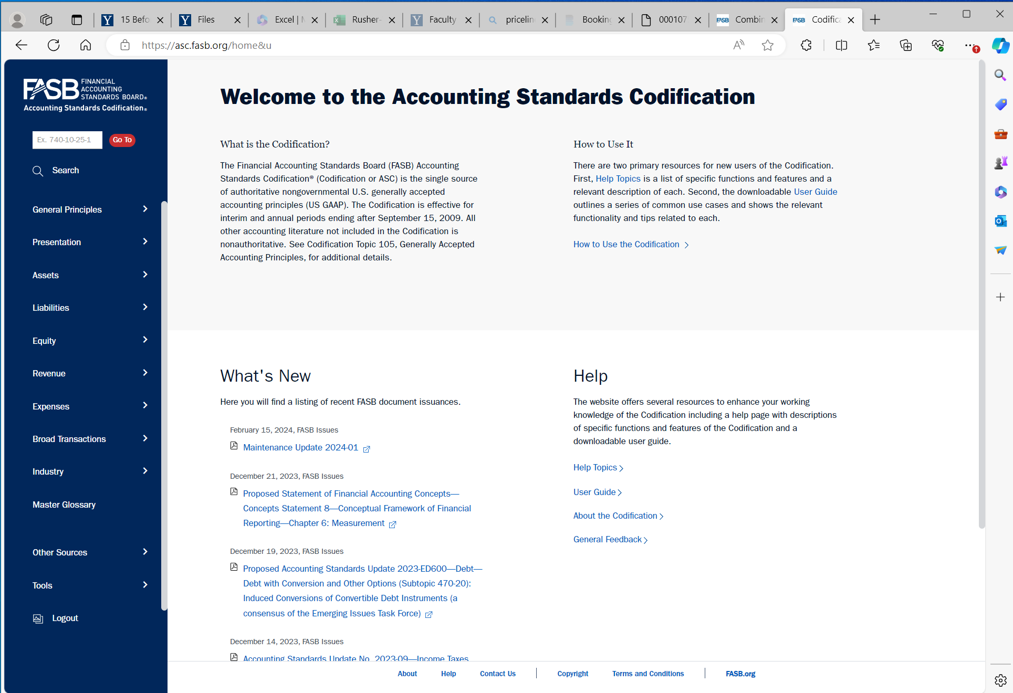

Select Revenue, then 606 Revenue from Contracts with Customers
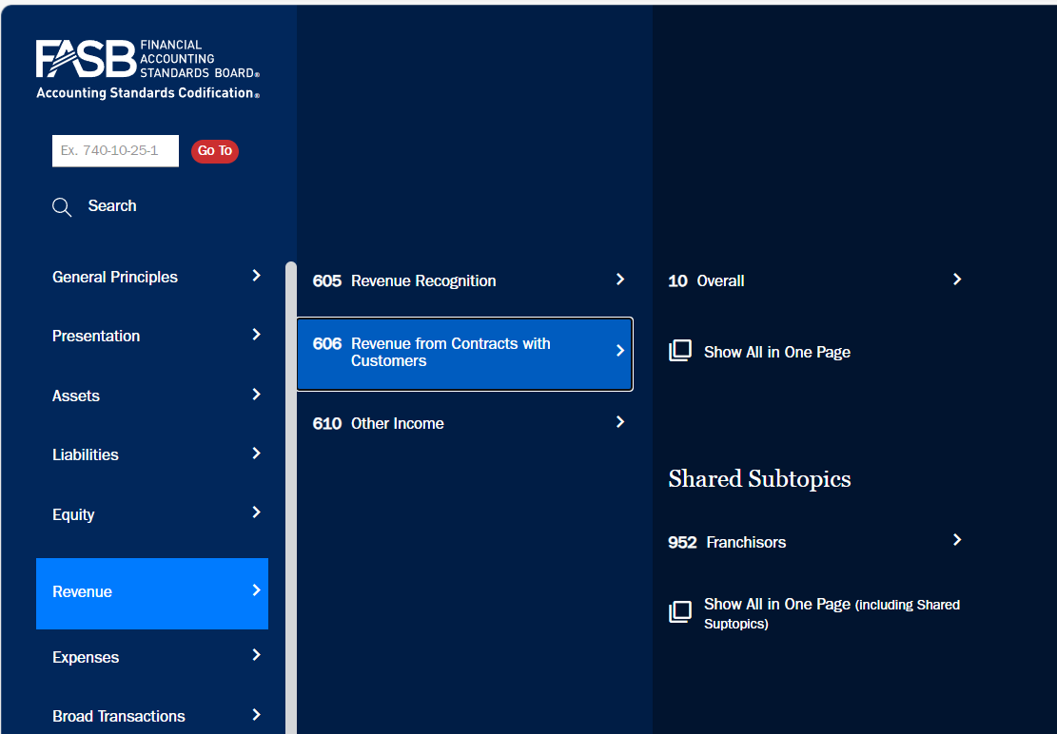
Select Show All in One Page to get:
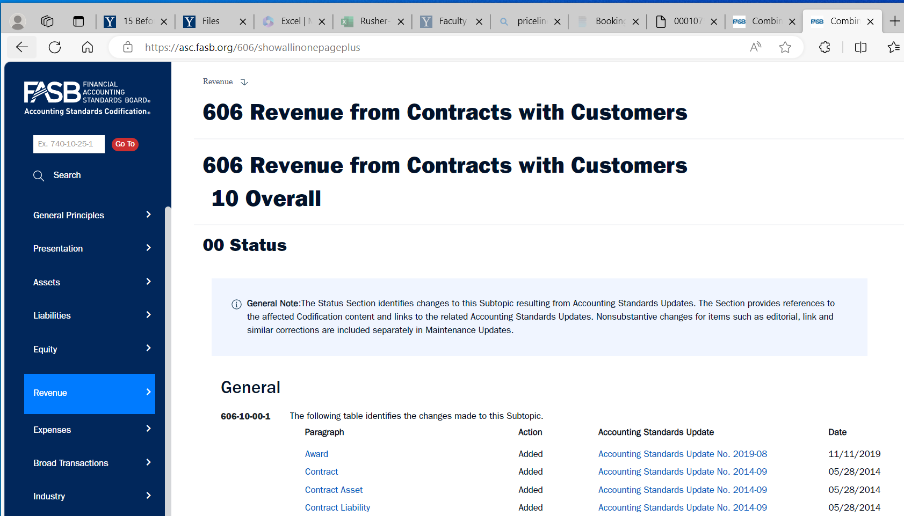
Then scroll to what you need to read.

OR:
Select 10 Overall to get:
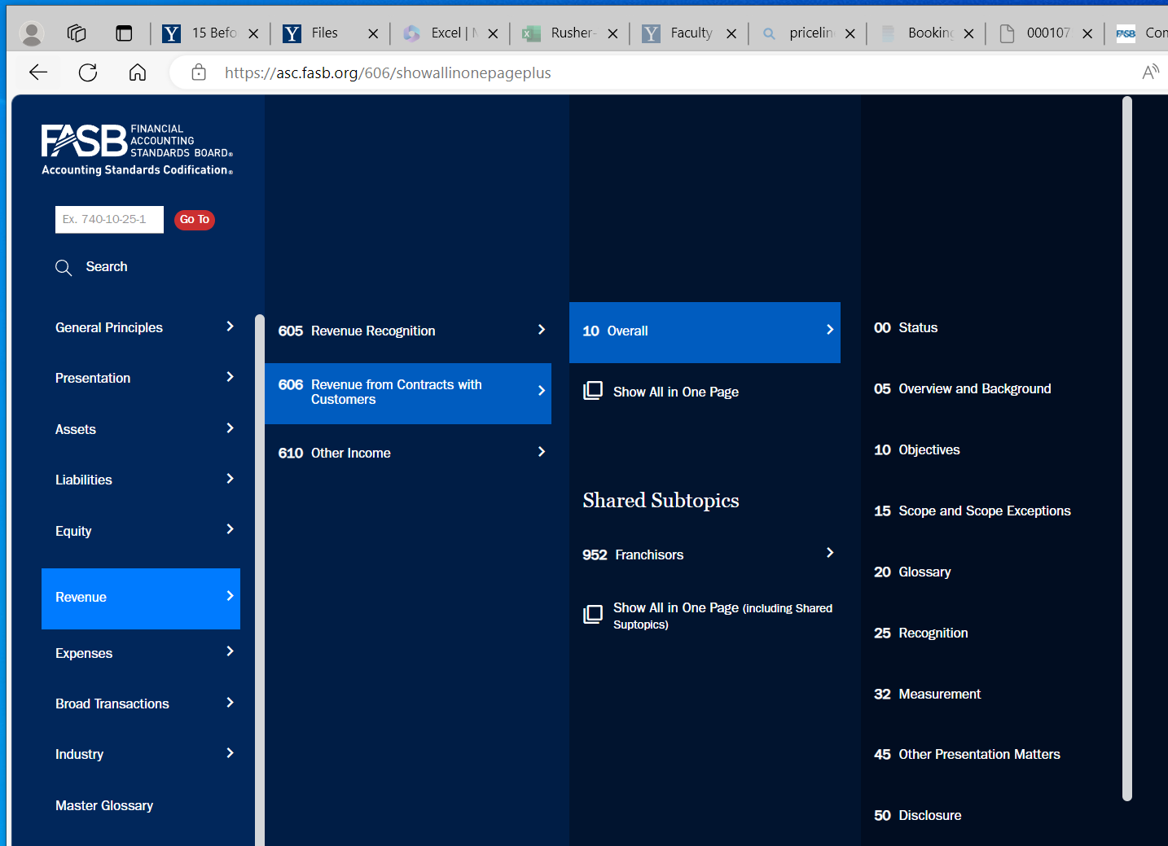
Then read:
606-10-05 Overview and Background
606-10-10 Objectives
606-10-15 Scope and Scope Exceptions
606-10-25 Recognition
606-10-32 Measurement
606-10-45 Other Presentation Matters
606-10-50 Disclosure
606-10-55 Implementation Guidance and Illustrations

NOTE: at some point in your drill-down the bottom of the page contains this:
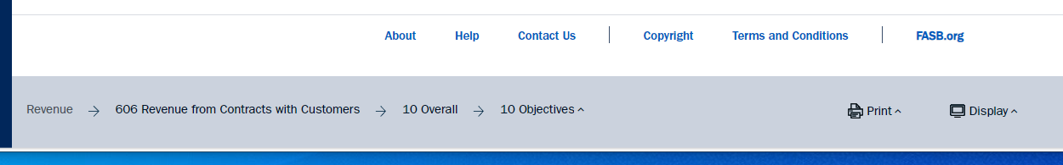
You can then navigate by selecting an item from the bottom left:
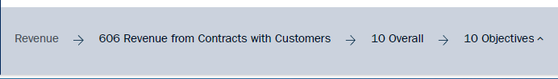
If you can get this page, you will be set:
